H.T No
Regulations:
A17

Sreenidhi Institute of Science and Technology
(An Autonomous Institution)
Code No: 6A242 Date: 14-July-2021 (AN)

B.Tech I-Year II- Semester External Examination, July - 2021 (Supplementary)
NETWORK ANALYSIS (ECE and ECM)

Time: 3 Hours Max.Marks:75

Note: a) No additional answer sheets will be provided.
b) All sub-parts of a question must be answered at one place only, otherwise it will not be valued.
c) Missing data can be assumed suitably.

ANSWER ANY 5 OUT OF 8 QUESTIONS. EACH QUESTION CARRIES 15 MARKS.

Bloom's Cognitive Levels of Learning (BCLL)

Remember | L1 | Apply | L3 | Evaluate | L5
Understand | L2 | Analyze | L4 | Create | L6

 |  |  | BCLL | CO(s) | Marks
1. | a) | Apply mesh analysis to find i₁ and i₂.  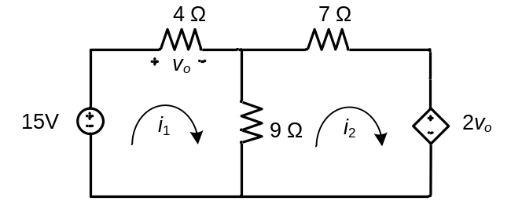 | L3 | CO1 | [8M]
 | b) | Evaluate R_{eq} for the circuit shown using star delta transformation  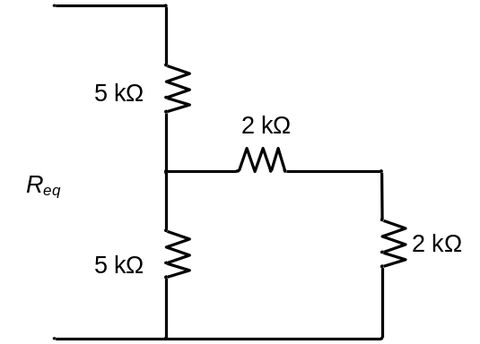 | L5 | CO1 | [7M]
2. | a) | A coil takes a current of 1 ∟60⁰ (lag) from 100V, 60Hz supply. Calculate its inductance, resistance and impedance. | L4 | CO2 | [8M]
 | b) | A non-alternating periodic waveform has been shown in the below figure. Calculate its form factor.  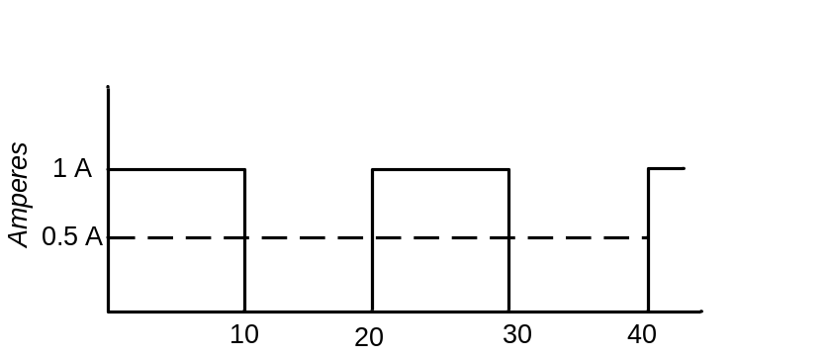  t | L4 | CO2 | [7M]
3. | a) | Explain dot convention in coupled coils. | L2 | CO3 | [8M]
 | b) | Two coupled coils have k= 0.8, N₁= 500 and N₂=1000 turns. The mutual flux being 0.9wb. Find the primary flux. If the primary current is 10A, find the primary coil inductance. | L3 | CO3 | [7M]
4. | a) | State and Explain Superposition Theorem. | L1 | CO4 | [8M]
 | b) | Find the Thevenin’s equivalent circuit of the network shown at terminals a-b.  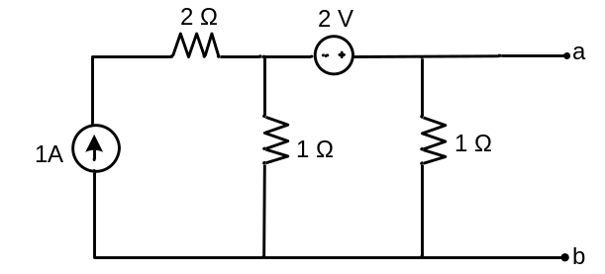 | L3 | CO4 | [7M]
5. | a) | Obtain the Y-parameter of the network shown in the below figure.  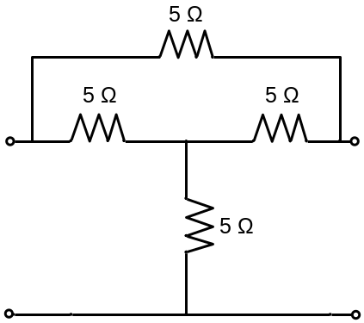 | L4 | CO5 | [8M]
 | b) | Derive the Z-parameters of a series connection of two Two-port networks. | L3 | CO5 | [7M]
6. | a) | Determine the step response of an R-L-C series circuit using differential equation approach. | L3 | CO6 | [8M]
 | b) | Using Laplace transforms find the transient solution of an RL series circuit when excited with a DC voltage source. | L4 | CO6 | [7M]
7. | a) | Explain the method of Super node analysis for an electrical circuit. | L2 | CO1 | [5M]
 | b) | A coil having an inductance and resistance of 50mH and 100Ω is connected in series with a capacitor and a 100V, 1kHz source. Obtain the value of capacitance that will cause resonance in the circuit. Find the circuit current at resonance frequency. | L3 | CO2 | [5M]
 | c) | Explain the difference between the series and parallel magnetic circuits. | L2 | CO3 | [5M]
8. | a) | State Reciprocity theorem and explain. | L1 | CO4 | [5M]
 | b) | Explain about Two port network connections in cascaded configuration. | L2 | CO5 | [5M]
 | c) | Derive the transient response in a parallel RC circuit when excited with a sinusoidal current source. | L3 | CO6 | [5M]

-- 00 -- 00 –

